Lab Report – 7

Part A: Counter

Moida Praneeth Jain (2022101093, Group 4, Table 16)

**Objective**

* To assemble and test a shift register by making a counter to count from 0 to 255 using Arduino.

**Electronic Components Required**

* LEDs
* Resistors
* Wires
* Arduino Uno
* 8 bit shift register (IC 74595)

**The Reference Circuit**

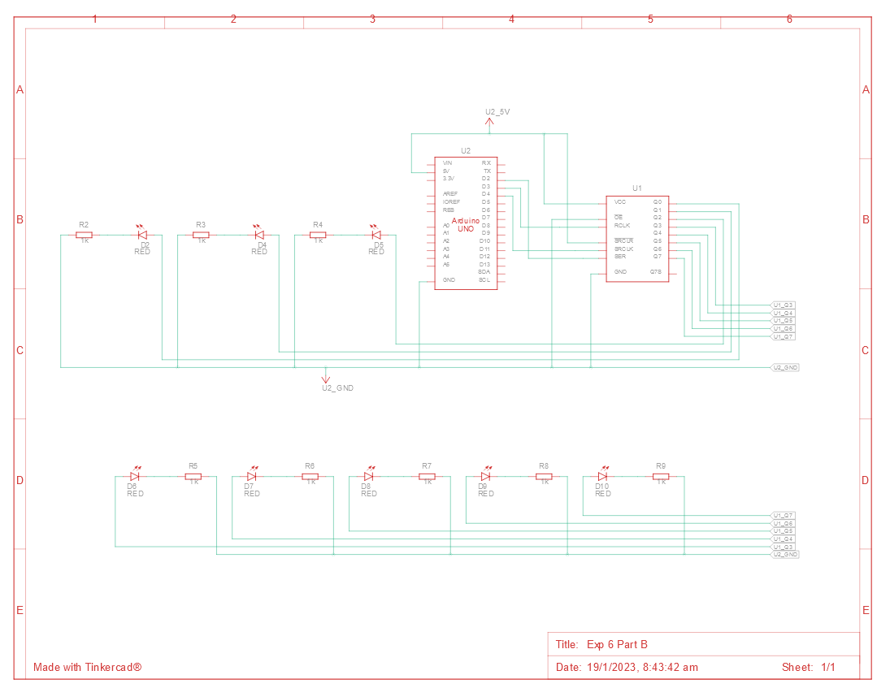

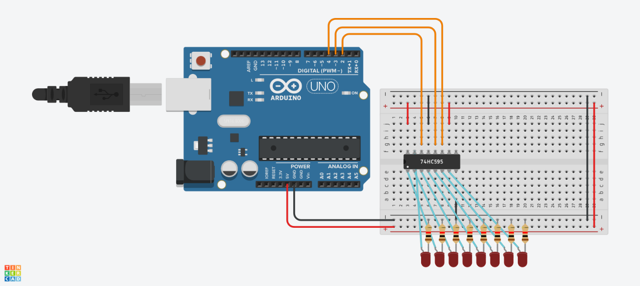

**Procedure**

* Connect the power and ground of the IC to VCC and GND of the Arduino using red and black wires respectively.
* Connect the output enable of the IC to GND.
* Connect the shift register clear to VCC.
* Connect the outputs of the shift register to LEDs’ anodes.
* Connect the cathodes of the LEDs to GND through resistors.

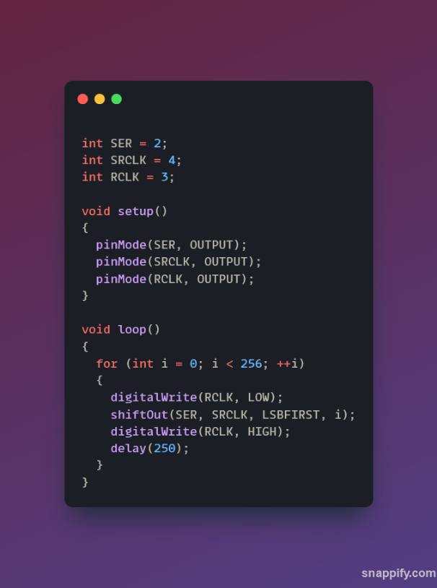

**Observation**

* The counter counts from 0 to 255 and then resets back to 0.

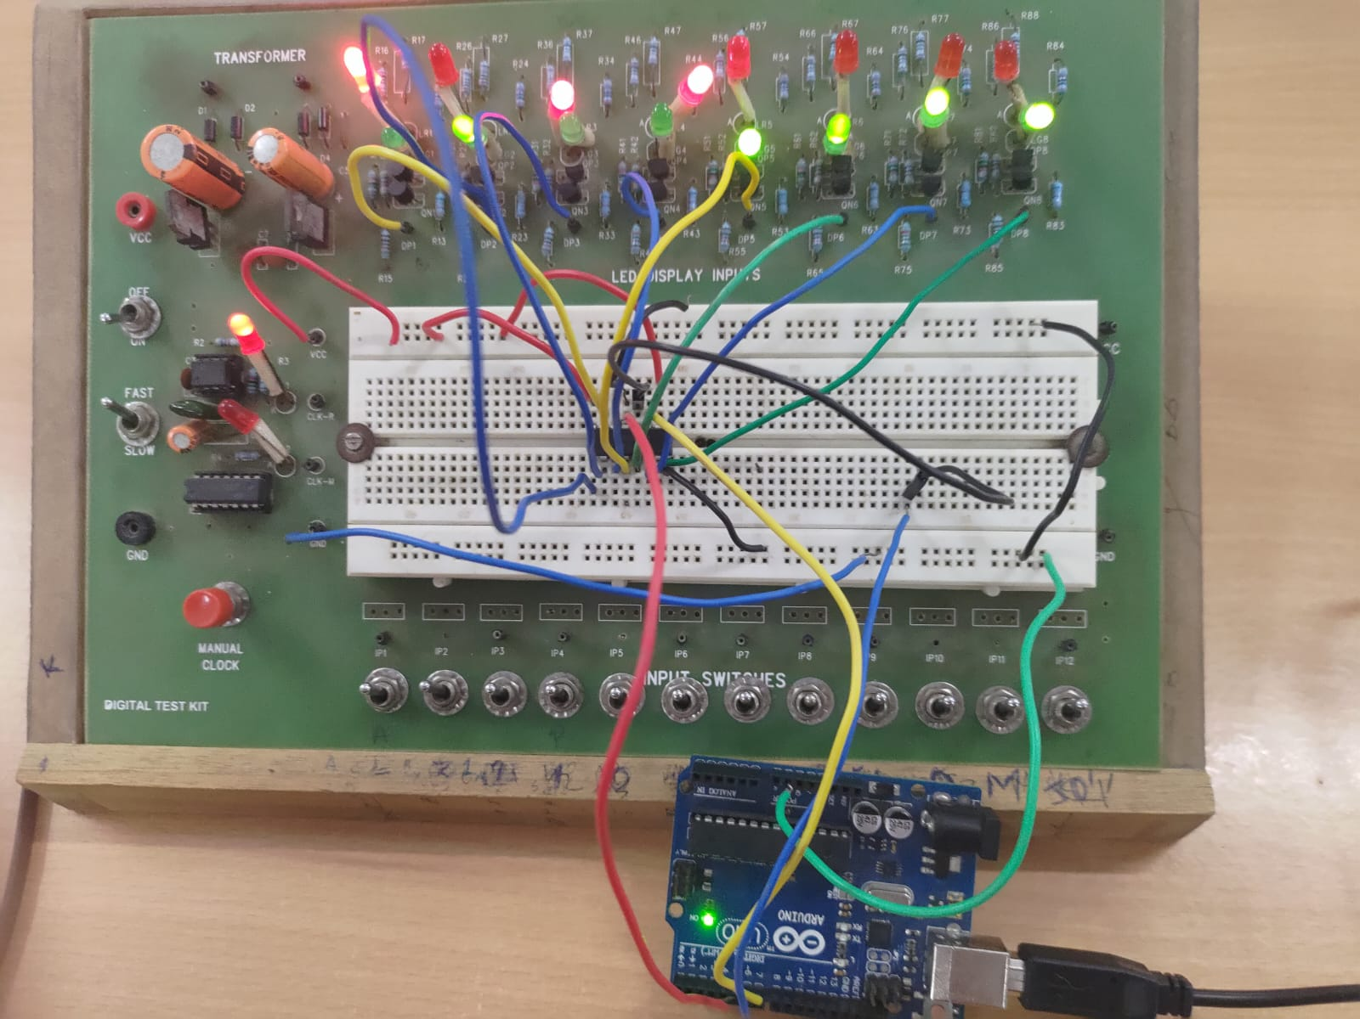

**Conclusion**

* The counter is working as expected

TinkerCAD simulation link:

<https://www.tinkercad.com/things/1QTRp9JFXto-exp-6-part-b/editel?sharecode=4wrRdJx1CK-5cJNRZyqYzbq2uIDtTqBgGInFnhP1Vlk>

Part B: Corresponding LED Selector

Moida Praneeth Jain (2022101093, Group 4, Table 16)

**Objective**

* To select and turn on the LED using shift register that has been inputted through the serial monitor.

**Electronic Components Required**

* LEDs
* Resistors
* Wires
* Arduino Uno
* 8 bit shift register (IC 74595)

**The Reference Circuit**





**Procedure**

* Connect the power and ground of the IC to VCC and GND of the Arduino using red and black wires respectively.
* Connect the output enable of the IC to GND.
* Connect the shift register clear to VCC.
* Connect the outputs of the shift register to LEDs’ anodes.
* Connect the cathodes of the LEDs to GND through resistors.

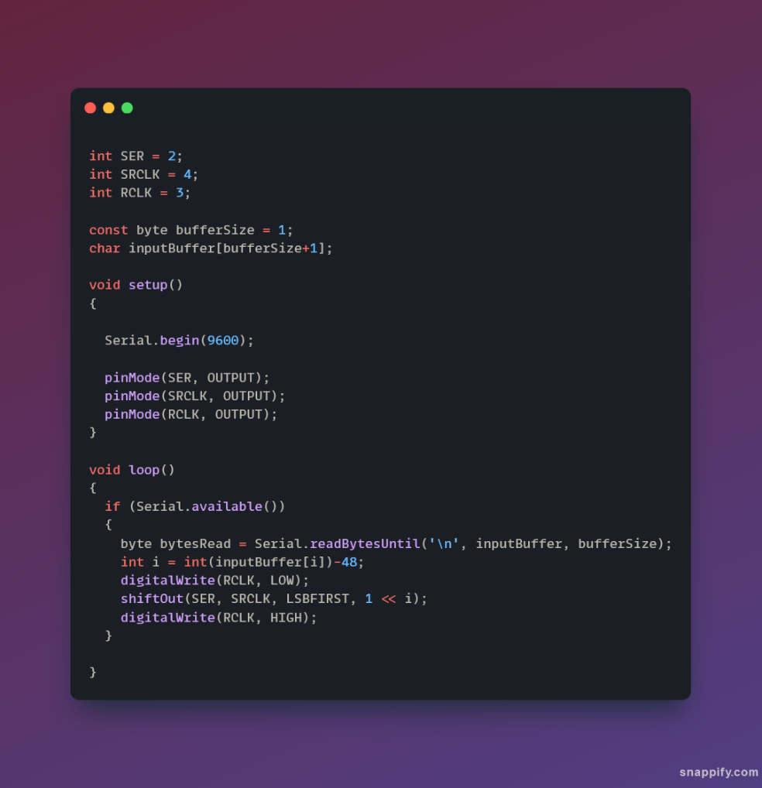

**Observation**

* On inputting an integer, the corresponding LED turns on, while all the other LEDs turn off.

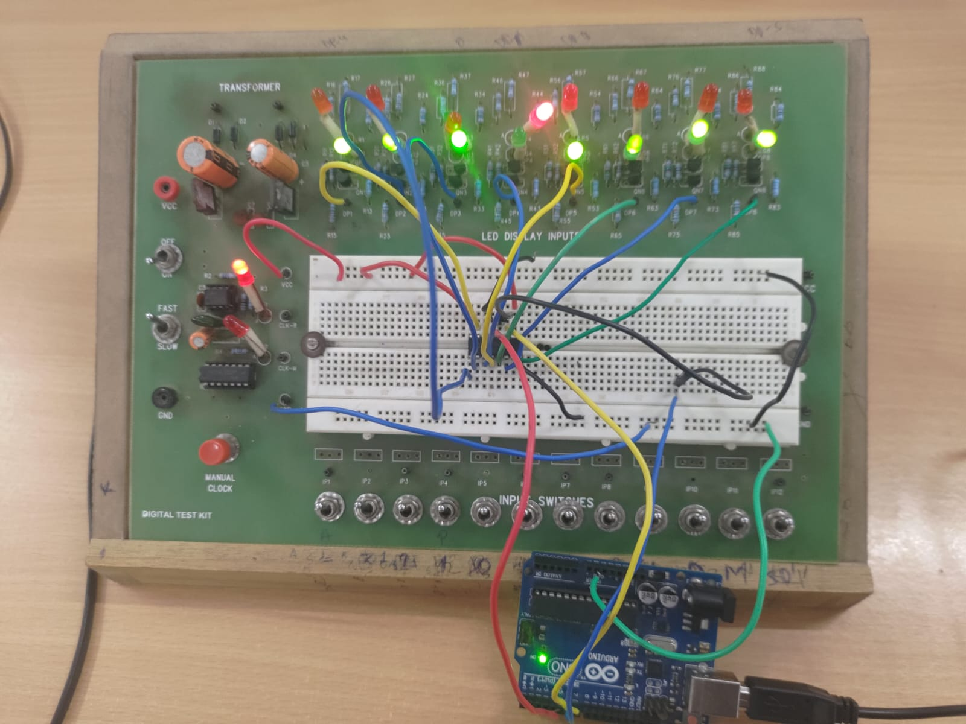

**Conclusion**

* The corresponding LED selector is working as expected.

TinkerCAD simulation link:

<https://www.tinkercad.com/things/1QTRp9JFXto-exp-6-part-b/editel?sharecode=4wrRdJx1CK-5cJNRZyqYzbq2uIDtTqBgGInFnhP1Vlk>

Part C: Binary Cell for RAM

Moida Praneeth Jain (2022101093, Group 4, Table 16)

**Objective**

* To build and test a binary cell for RAM built using RS Latch.

**Electronic Components Required**

* LEDs
* Resistors
* Wires
* Power Supply
* Switches
* Triple 3-Input AND Gate (7411)
* Quad NOR Gate (7402)

**The Reference Circuit**

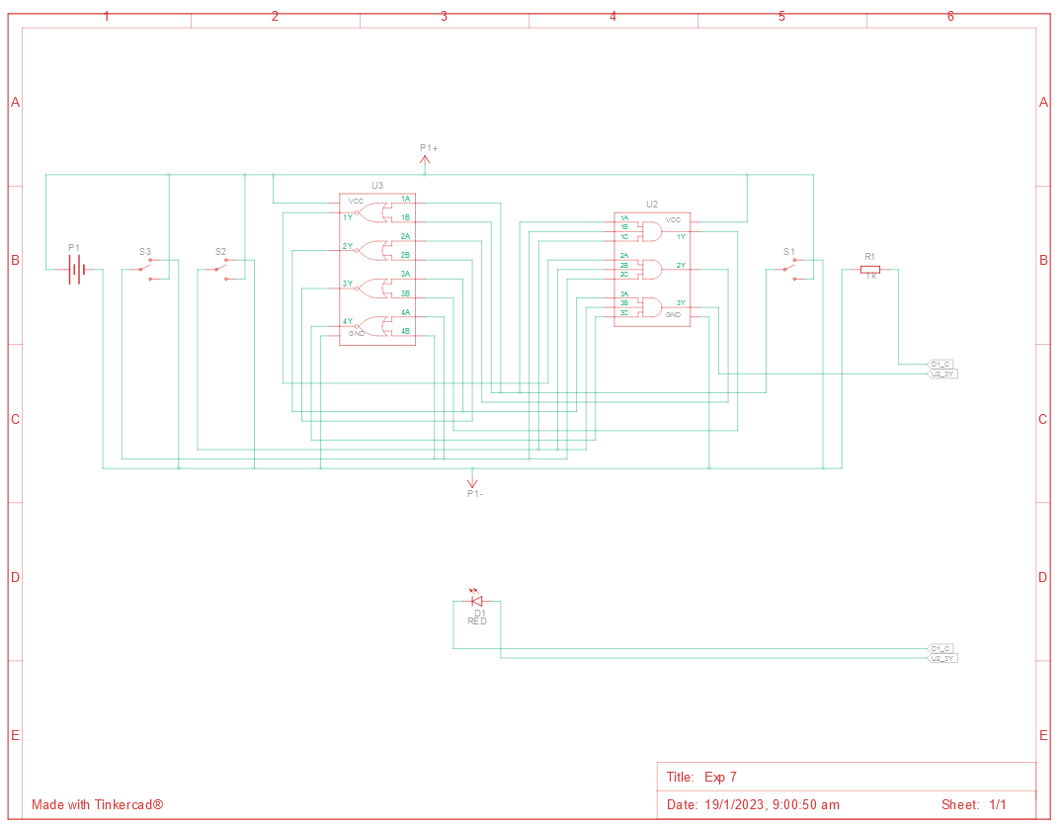

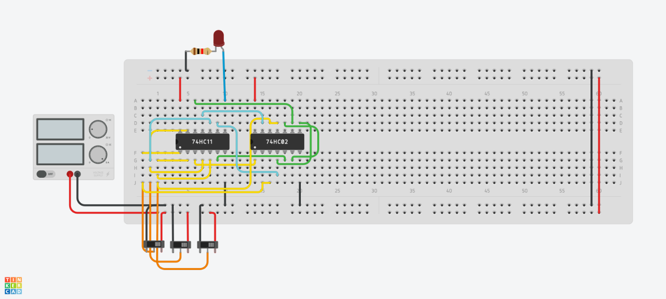

**Procedure**

* Connect the power and ground of the ICs to VCC and GND of the Power Supply using red and black wires respectively.

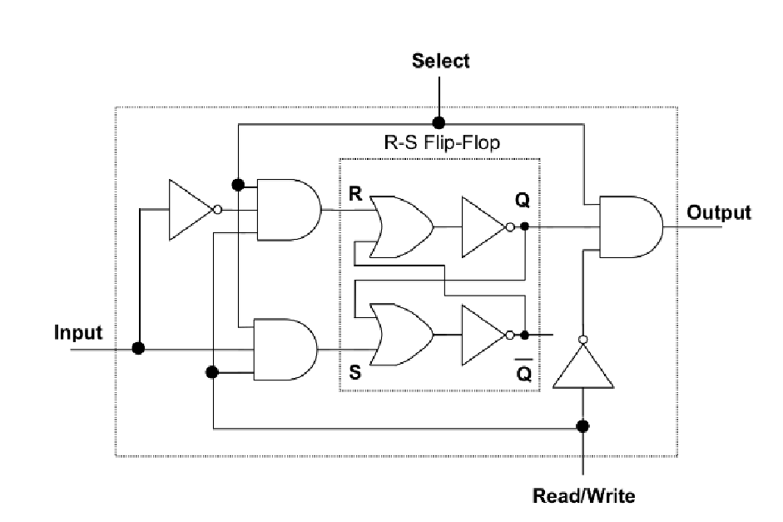

* Connect the wires according to the diagram above.

**Observation**

* When select is on and cell is in write mode, the input is stored in the RS Latch.
* When select is on and cell is in read mode, the value stored in the RS Latch is outputted.
* When select is off, in all conditions the output is 0.

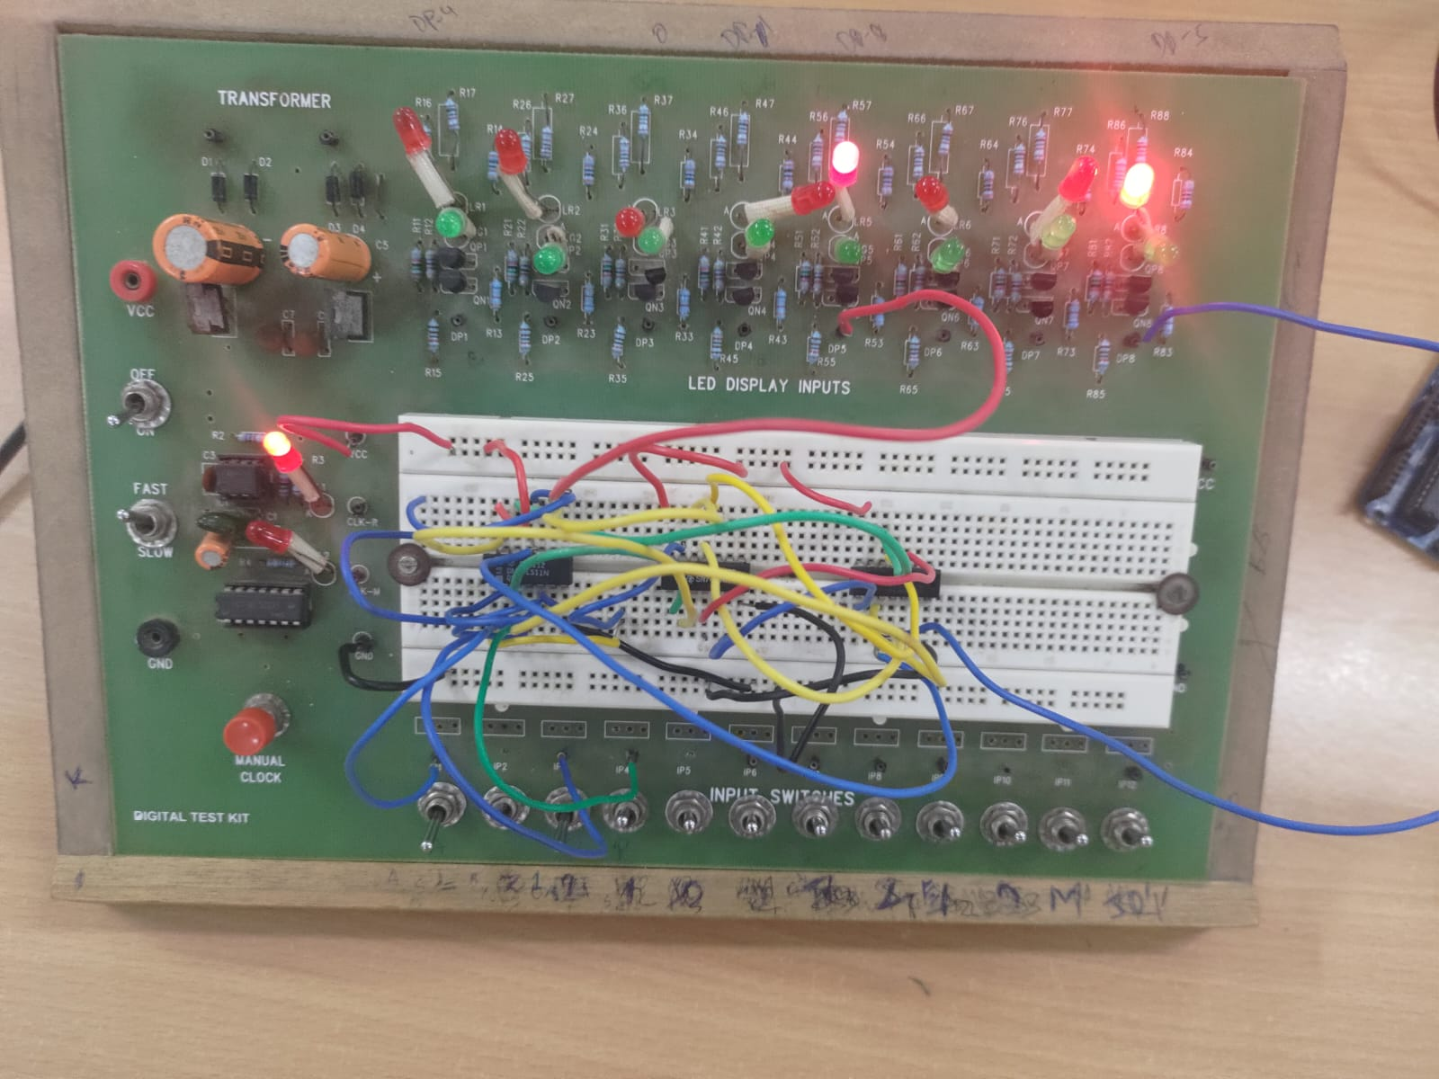

**Conclusion**

* The binary cell for RAM is working as expected.

TinkerCAD simulation link:

<https://www.tinkercad.com/things/dfmJaBom0sE-exp-7/editel?sharecode=iNRs-sQZHuvtk71K0Iq6-A1NI0iv57PvkHClUtkYwFU>